Sandra Hansen  International, Environmental Papermaker | 227 W. 19th Street, Holland, MI 49423  cell 1 423 276-0065  email: artnomad@sandrahansen.com  webpage: www.sandrahansen.com  https://www.facebook.com/SandraArtnomad/  www.artistsculturalexchange.com
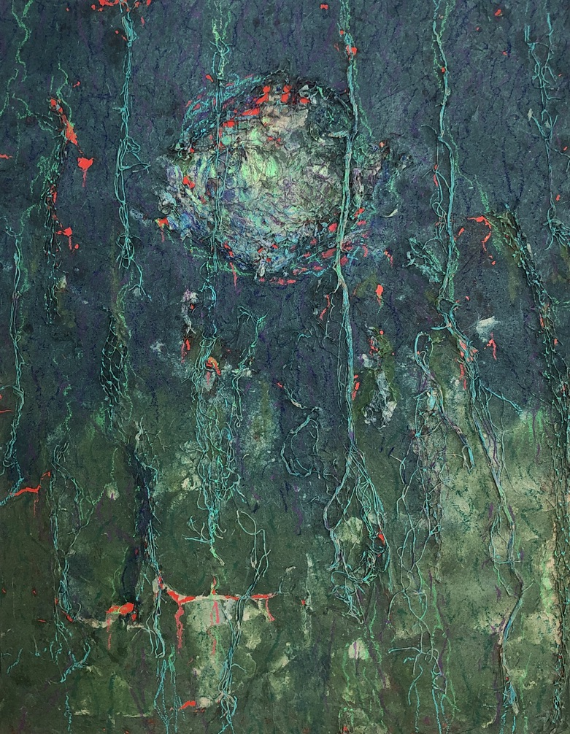
I became a papermaker when I discovered the magic of creating super thin, translucent, paper from leaves and bark. Paper can be made in a completely environmentally sound manner and can be absolutely gorgeous. Its rich texture; its delicate gauzy effect, and its versatility is engrossing. Paper has the ability to bring alive the horrendous problems of pollution simply by putting plastic bags into the pulp. In 2019 I became the first person ever to make paper from the Wollemi Pine tree. Ask me how.

Education

MFA | 2016 | Kendall College of Art and Design  Grand Rapids, Michigan | Painting
BFA | 2013 | Kendall College of Art and Design  Grand Rapids, Michigan | Painting, Drawing
Art Studies | 2009 | Kendall College of Art and Design- Continuing Learning | Painting
Art Studies | 2005-2008 | Hope College  Holland, Michigan | Painting, Drawing
BFA | 1991 | Hope College  Holland, Michigan | Women’s Studies  Psychology
Associate | 1978 | Cincinnati Technical College, Cincinnati, Ohio | Mechanical Design
 | 1976-1978 | University of Cincinnati, OCAS campus, Cincinnati, Ohio | woodworking

Solo Exhibitions

2021 Lowell Area Arts Council, Lowell, MI
2021 Salt of the Earth, Fennville, MI
2019 Salt of the Earth, Fennville, MI
2018 Great Legs Winery, Holland, Michigan
2017 Inner Mongolia Art Museum, Hohhot, China
2011 LedØje-SmØrum, Musikforening, 25 Year Jubilee Concert at Kulturhuset i SmØrum, Copenhagen, Denmark
2009 American Center of American Embassy, Delhi, India
2009 Faculty of Visual Arts, Banaras Hindu University, Varanasi, India
2009 Gallery Una in Bjarred, Sweden
2006 University of Michigan, II Gallery in the Asian Art Gallery, Ann Arbor, Michigan

Group Exhibitions

2021 Kalamazoo Institute of Art, Kalamazoo, MI
2021 Festival, Grand Rapids, MI
2020 Lowell Area Arts Council, Michigan
2019 Forest Museum, Beijing, China
2019 Grand Rapids Festival, Grand Rapids, Michigan
2019 2 Open Studios exhibitions, Bilpin International Ground for Creative Initiatives, Bilpin, Australia
2018 Grand Rapids Festival, Grand Rapids, Michigan
2018 Her Vision, En Lei Museum, Beijing, China
2017 Jaipur Kala Chaupal, Jaipur, India
2016 Grand Rapids Festival, Grand Rapids, Michigan
2016 Fed Gallery, Kendall College of Art and Design, Grand Rapids, Michigan
2014 I Curated the Felt Mansion Holiday Show, Saugatuck, Michigan.
2014 Jaipur Art Festival, Jaipur, India
2013 Fusion, DeVos Hall, Grand Rapids, Michigan
2013 Banaras Club Varanasi, India
2013 Lane Eleven Gallery, Varanasi, India
2012 Challenging Expectations, Kendall College of Art and Design Grand Rapids, Michigan
2011 ARTPRIZE 2011, Grand Rapids, Michigan, Emmett Till Memorial Triptych
2009 Holland Area Arts Council Juried Show, Holland, Michigan
2006 Holland Area Arts Council Juried Show, Holland, Michigan

Articles and Media

Chang Mingzhu + Mi Jing | Paper Art Museum | Pulp · | Beijing, China | January 9, 2020
Yang Weimin | Art & Trip Magazine | Beijing China | 2018 No 6, issued in January 2019
 | Television Interview for Her Vision Exhibition | En Lei Art Museum, Beijing, China | 1/21/2018
Adora Trostle | http://www.nyundressed.com/artist-sandra-hansen/ | New York Undressed
Sophia Vander Kooy | September Earth Week Heightens Action  En Lei Museum | Anchor, Hope College  3/18/2018 | 9/2017
Sohu | ▎Sino-American Artist Series Solo | Inner Mongolia Art Museum 7/6/2017  Hohhot, China  www.sohu.com/a/154916279_726862 | 7/10/2017

Phoenix Information | Prairie Youth Forest Green -Inner Mongolia Art Museum holds exhibition of Chinese and American artists  http://news.ifeng.com/a/20170710/51405569_0.shtml | Inner Mongolia Art Museum  Hohhot, China  www.sohu.com/a/154916279_726862 | 7/6/2017
Sina  Editor: Mei Xu | Sino-American Artist Series Solo Exhibition Held in Inner Mongolia Art Museum  http://k.sina.com.cn/article_2810373291_a782e4ab0340056il.html | Inner Mongolia Art Museum  Hohhot, China  www.sohu.com/a/154916279_726862 | 7/11/2017
Catherine  Behrendt | WZZM TV, Channel 13 Take 5 | http://www.wzzm13.com  /video/1128740302001/0/ Art-Prize-Emmett-Till/htm | 08/26/11
Lori Timmer | The Return of ArtPrize | Holland, Michigan Sentinel newspaper | 9/11/11
Jeffrey Kaczmarczyk | ArtPrize 2011: The phenomenon unfolds today | Everything Michigan Mlive.com | 9/21/11
Steve Ralph | Art Nomad: Holland artist exhibits, paints and teaches art in India | Holland, Michigan Sentinel newspaper | 1/06/10
 | Jagran Josh: Your Guide to Success | Hindi newspaper Banaras, India | 11/23/09
Shandra Martinez | Artist heads to India, offering acrylics and one-woman show | The Grand Rapids Press, Michigan newspaper  Section N, page 1 | 10/16/05

Artist Residencies

2019 Semi Space, Beijing, China
2019 Bilpin International Ground for Creative Initiatives (BigCi), Bilpin, Australia
2018 Artists Cultural Exchange I hosted an Artist Residency in Southwest Michigan in September 2018
2018 Untitled Space, Jinze near Shanghai, China
2017 Jaipur Kala Chaupal, Jaipur, India
2015 Casa Masaccio, San Giovanni, Valderno, Italy
2015 Founder, Artist Cultural Exchange. A nonprofit organization created to expedite cultural exchanges between artists in different countries.
2013 Jaipur Art Festival, Jaipur, India
2005 Assi Ghat Varanasi, India

Teaching Art and Other Experiences

2018-present Students in my own studio and online
2019 Three Shadows, Beijing, China two-day papermaking workshop
2019-present Papermaking and Encaustic Classes at Academy of Art and Design, Grand Rapids, MI
2015-2017 Kendall College of Art and Design, Continuing Learning classes
2014 I organized International Art Camps, with two-day workshop/residencies, with Dr. Suresh K. Nair and others in Varanasi, India; another with Dr. Naval Krishna at Jarwahal Kala Kendra, Jaipur, India and in Bikaner, India
2013 Lund, Sweden - community class for adults
2009 Bangkok and Khon Kaen, Thailand for children and adults at a community center
2005-2007 Southpoint School, Nirman, Varanasi, India. Guest teacher for children and adults
1989-2005 Women’s History ALIVE! A one-woman show touring the U.S. with my original scripts and costumes.
1978-1980 I worked at Lyon and Healy in Chicago building harps, which gave me woodworking experience and a knowledge of tools.

Continuing Education

11/21 I took a month-long class with Amy Richards on Kozo paper making in the Japanese style.
2019 5 day workshop on Flax paper making at Carriage House Paper

Gallery Representation

2019-Present Forest Museum, Beijing, China
2021-Present Art Cats Gallery Muskegon MI
2018-present Fernwood Gallery, Fennville, MI
2018 Unique Boutique, Muskegon, MI
2017-present Flat River Gallery and Frame and Matting, Lowell, MI
2015-2016 Huber’s Fine Art Gallery, Holland, MI
2006-2007 Reflections Fine Art Gallery, Holland, MI

Collections

Forest Museum, Beijing, China.
The Inner Mongolia Art Museum, Hohhot, China
Works held in private collections in Australia, Spain, Canada, China, Denmark, Germany, India, Japan, Sweden, Taiwan, United Kingdom, and the United States
Awards

2014 Honorable Mention for "Algae Bloom" at Holland Area Arts Council's All Michigan Regional Show. Holland, Michigan.
2013-2016 Kendall College of Art and Design MFA Portfolio Prize, Grand Rapids, Michigan
2013 Kendall College of Art and Design Excellence in Painting Award, Grand Rapids, Michigan
2010-2013 Kendall College of Art and Design Portfolio Prize, Grand Rapids, Michigan
2009 Honorable Mention for "Dawn on the River Ganges" Holland Area Arts Council's All Michigan Regional Show, Holland, Michigan
1991 Phi Beta Kappa Hope College, Holland, Michigan
1991 1st and 3rd Prize Women’s History Writing Contest, Hope College, Holland, Michigan

Organizations

2021 International Society for Experimental Artists (ISEA) attended conference and workshops
2020-Present The International Association of Hand Papermakers and Paper Artists (IAPMA) is the world leading organization for paper artists.
2020-Present Hand Papermaking
2020-Present North American Hand Papermakers

