
Sandra Hansen
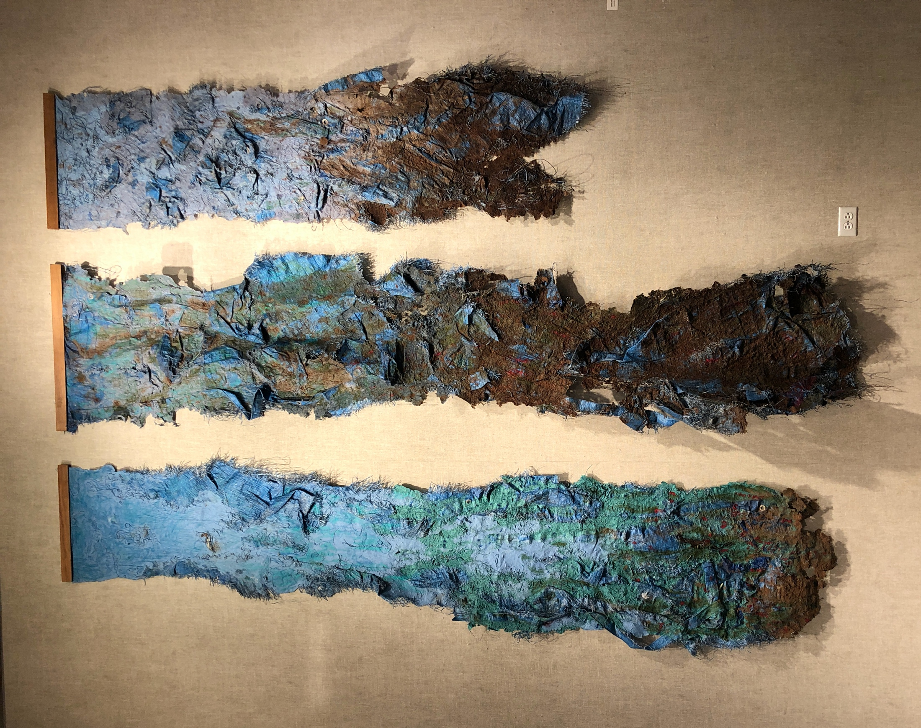
Bio 2022

Sandra Hansen is an international, Environmental artist in many mediums, optimist, and world traveler. The central theme of Sandra’s art embraces the beauty of water, despite being imbued with plastics and toxic elements. Hansen has exhibited, had artist residencies, visited art museums and galleries, and taught classes in thirty countries around the world. At an artist residency outside of Sydney, Australia; Hansen became the very first person in the world ever, to make paper from the Wollemi Pine tree. She has been to China three times, including a solo show at the Inner Mongolia Art Museum and an artist residency at Untitled Space near Shanghai. In 2019 Hansen had an exhibition at the Forest Museum, and at the Semi Space artist residency, both in Beijing. While in Beijing Hansen held a two-day workshop on papermaking at the Three Shadows Art Gallery and Residency. Hansen has been to India on thirteen trips to exhibit, teach, paint, and participate in artist residencies. Other countries that she has had exhibitions, residencies, or taught art were in Denmark, Sweden, Italy, United States, and Ireland. Most recently, during the pandemic, Sandra has taught online art classes to students in the US and China.

